HACRUS

THE ARCANOS
OF THE HOUSE
EDITORIAL SERIES 01 • 2026
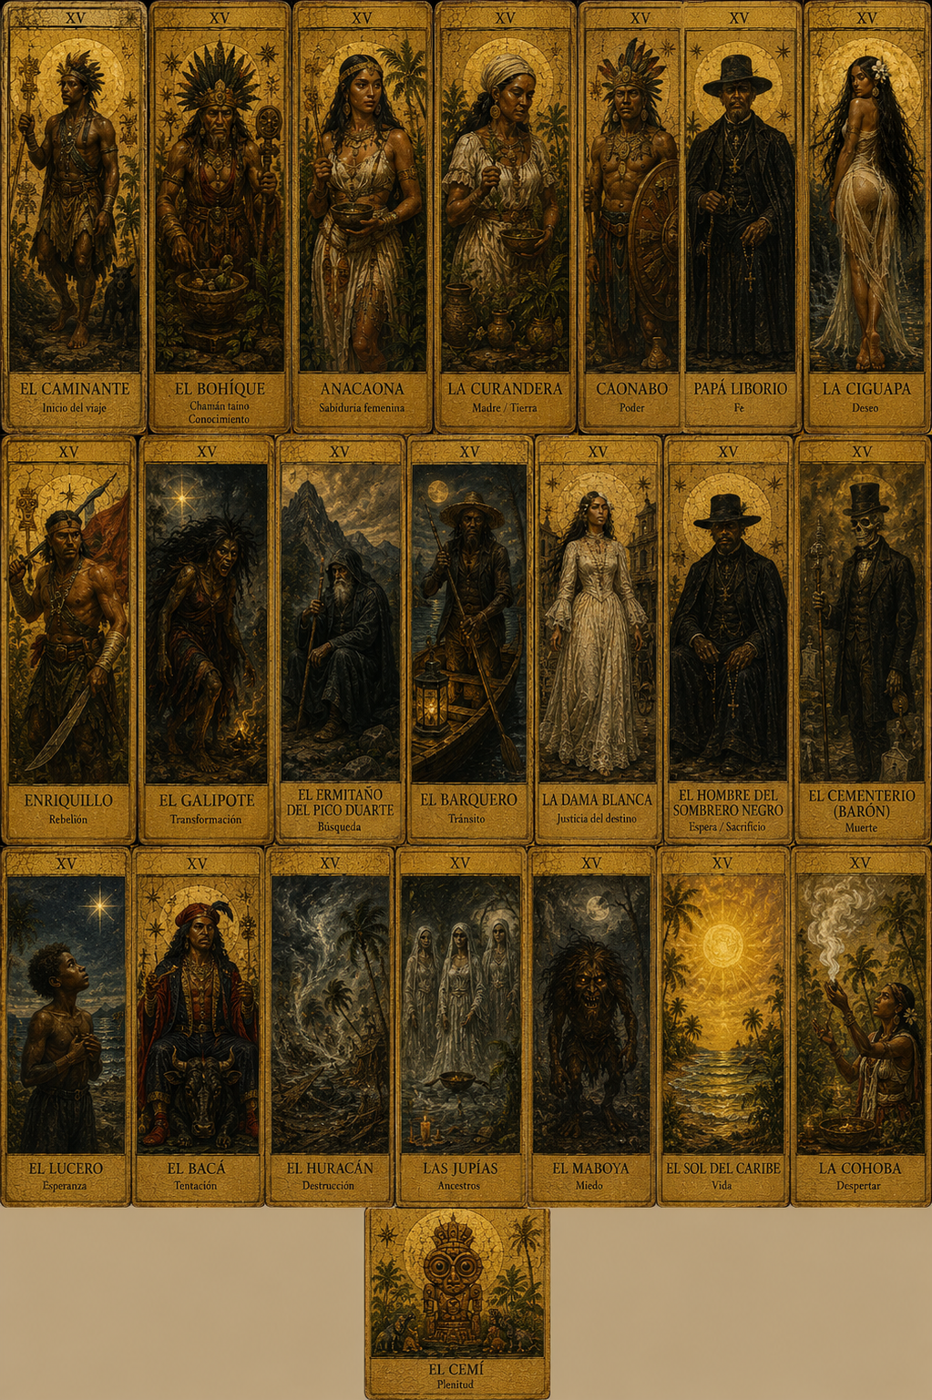
Dominican history, folklore, and memory transformed into a contemporary tarot system.
TAROT ART 2026 • TORINO

Contents
01 The Arcanos of the House: the secret country contained in 78 cards
02 The Price of Desire: The Bacá and the Ciguapa
03 The Dead Do Not Leave: Papá Liborio and the Jupías
04 When Night Takes Form: The Man in the Black Hat and the White Lady

Editorial calendar
Date | Article | Purpose
18 Aug 2026 | The Arcanos of the House | World and research
20 Aug 2026 | The Bacá and the Ciguapa | Pact and autonomy
25 Aug 2026 | Papá Liborio and the Jupías | History and memory
27 Aug 2026 | The Man in the Black Hat and the White Lady | Fear and apparition
Exhibition: August 28–September 3. Opening: August 29, 5:30 p.m. Con/Temporary Spaces Santa Teresa, Via Santa Teresa 10/d, Turin.

The Arcanos of the House: the secret country contained in 78 cards
A Dominican tarot does not begin by asking what will happen tomorrow. It begins by asking what is still alive within us: the mountain, the dead, Taíno memory, resistance, fear, and the stories a family speaks only in a lowered voice.
Some houses preserve photographs. Others preserve silences. In certain homes, a grandmother knows exactly when the courtyard should not be crossed; someone remembers a promise made before a candle; a door closes without wind and nobody asks why.
The Arcanos of the House begins in that territory—the place where family history, Dominican folklore, and spiritual imagination cease to be separate subjects. It is neither an exotic illustration of the Caribbean nor a mechanical substitution of European names with local characters. It is an artistic investigation into the images through which a culture learns to fear, resist, care, remember, and transform.

The number beneath the mystery
A conventional tarot has 78 cards: 22 Major Arcana and 56 Minor Arcana. The minors are arranged in four suits of 14 cards—ten numbered cards and four court cards. This structure was consolidated long after the first tarot decks appeared as trick-taking games in fifteenth-century Italy. Their dominant association with divination and occult practice came centuries later, especially from the late eighteenth and nineteenth centuries onward.
That history matters because it frees tarot from the fiction of purity. Tarot has always traveled. It has been a game, a luxury object, a popular language, an esoteric tool, a graphic artwork, and a device for conversation. Its figures have changed clothing, architecture, race, and landscape whenever artists needed them to answer a different world.
The Arcanos of the House enters that tradition of transformation. The project proposes 22 Dominican major figures and a minor structure inspired by four Caribbean forces: Mountain or Earth, Sea or Water, Wind, and Fire. The working archive currently contains 72 received images, 59 unique compositions, and 13 groups of variants or duplicates. They are not 59 disconnected pictures. They are the first evidence of a system.

Not decorating tarot, but arguing with it
The starting question is not, “Which Dominican character resembles the Hermit?” It is more uncomfortable: “What does solitude mean on an island marked by migration, mountains, occupations, hurricanes, and departures?” From there may emerge the Hermit of Pico Duarte, but also the Ciguapa as impossible orientation, Papá Liborio as faith and resistance, the Bacá as pact and debt, and the Jupías as the persistence of those who no longer possess bodies.
Every figure requires three layers to remain distinct:
- Historical record: dates, documents, identifiable testimony, and political context.
- Oral tradition: changing narratives that belong to no single version or author.
- Artistic interpretation: the meaning the figure acquires within this tarot.
The distinction does not diminish mystery; it deepens it. Knowing that an early printed work titled La Ciguapa appeared in Santo Domingo in 1866 does not destroy the being. It reveals that she has moved in and out of writing for at least a century and a half. Knowing that Olivorio Mateo’s movement began in 1908 and that its leader died in 1922 prevents Papá Liborio from being reduced to fantasy: before he became an arcano, he was a man, healer, leader, and target of persecution.

A house is not a motionless museum
“House” does not describe only a building. It is a technology of memory. What was inherited lives beside what was never explained; Catholic, Indigenous, and African-derived practices share space with yard remedies, photographs of the absent, practical advice, and supernatural warnings.
This tarot therefore refuses a docile, sunlit Caribbean. Its palette holds aged gold, black, smoke, salt, rust, wet earth, and the red of a promise. Beauty remains, but never separated from the price that produced it. The image must seduce before revealing that something is watching from the background.
The project also refuses to treat “Taíno,” “African,” or “peasant” culture as decorative texture. Colonial accounts of Taíno spirituality were written inside conquest and unequal translation. They must be read with their limits exposed. Dominican-Haitian practices cannot be converted into horror props without remembering the border, slavery, racialization, and survival that shaped them.

What does a card do?
A card does not deliver a verdict. It creates friction.
Before the Bacá, the question may be: What prosperity am I willing to pay for, and who carries its cost? Before the Ciguapa: Am I lost, or am I following tracks designed to deceive the hunter? Before Papá Liborio: When does faith become community, and when does power begin to fear it? Before the Jupías: Which dead still organize the life of this house?
The reading occurs in the conversation between image, memory, and present time. Belief in prediction is not required. Yale describes tarot as visual, tactile, conversational, and auditory, as well as a technology for imagining and dismantling social worlds. That comes close to the heart of The Arcanos of the House: the cards do not dictate a Dominican destiny. They open a room that had been locked.

From archive to Turin
Five works—The Bacá, The Ciguapa, Papá Liborio, The Man in the Black Hat, and The White Lady—form the selection prepared for TAROT ART 2026 at Con/Temporary Spaces Santa Teresa in Turin. The collective exhibition runs August 28–September 3, 2026, with the opening on August 29 at 5:30 p.m.
There is a beautiful symmetry here. Tarot emerged as a visual game in fifteenth-century Italy. These Dominican figures now return to Italy as contemporary arcana—not to ask permission of tradition, but to show that tradition remains alive only when it can be inhabited, debated, and transformed.
The Arcanos of the House does not ask whether the Caribbean possesses enough mystery to enter tarot. It asks why it took us so long to recognize that it already had arcana of its own.
Call to action: Follow the series to enter, card by card, the stories of the Bacá, the Ciguapa, Papá Liborio, the Jupías, the Man in the Black Hat, and the White Lady.

LinkedIn version
A traditional tarot contains 78 cards: 22 Major Arcana and 56 Minor Arcana. But the number is only the architecture. The real question is: what memory lives inside the images?
The Arcanos of the House transforms Dominican history, folklore, and visual culture into a contemporary system. It does not simply replace European names with Caribbean characters. It asks what pact, orientation, faith, death, fear, and apparition mean on an island shaped by multiple memories.
The working corpus currently contains 72 images, 59 unique compositions, and 13 groups of variants. Its 22 major figures bring together historical people and beings from oral tradition. The minor arcana are being developed through four realms: Mountain, Sea, Wind, and Fire.
The research always distinguishes historical documentation, oral variants, and artistic interpretation. Precision does not eliminate mystery; it prevents mystery from becoming an excuse to erase history.
Five works are headed toward TAROT ART 2026 in Turin: The Bacá, The Ciguapa, Papá Liborio, The Man in the Black Hat, and The White Lady.
Tarot began as a visual game in fifteenth-century Italy. In August, these Dominican images return to Italy to demonstrate that symbols remain alive not by repeating themselves, but by learning to speak again.

Horizontal visual proposal
A 16:9 composition with the full arcana sheet emerging from an almost-black house. In the foreground, one face-down card on a table; six barely visible figures in the background. Condensed sans-serif type, aged gold, oxblood red. Short line: “The secret country contained in 78 cards.”
Suggested artwork: 01_imagenes_originales/03_planchas_y_conjuntos/plancha_conjunto_arcanos.png

References
• Victoria and Albert Museum. “A history of tarot cards.” Updated July 16, 2026. [source: vam.ac.uk]
• Yale Faculty of Arts and Sciences. “The worlds of tarot.” October 29, 2025. [source: fas.yale.edu]
• The Metropolitan Museum of Art. “Before Fortune-Telling: The History and Structure of Tarot Cards.” [source: metmuseum.org]
• The Arcanos of the House internal visual inventory, August 2026.

The Price of Desire: The Bacá and the Ciguapa
One promises wealth and collects in secret. The other walks backward so no one can know where she is going. Two Dominican beings reveal what power most wants to control: prosperity and freedom.
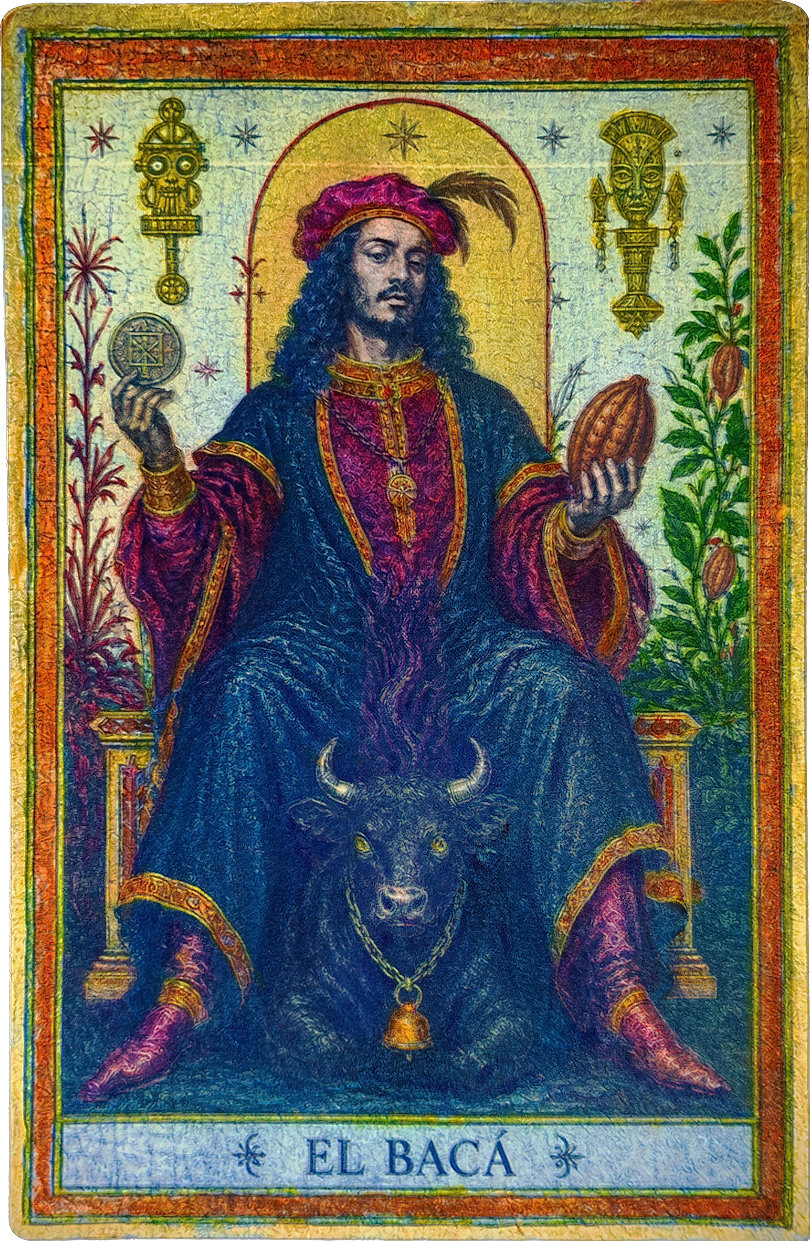
Some desires never arrive alone. They bring a shadow behind them.
In stories of the Bacá, wealth rarely appears innocent. Something changes hands: a promise, a body, an animal, a future life. In Ciguapa stories, the problem is not what can be bought but what cannot be captured. Her feet point backward and turn every footprint into a lie meant for the hunter.
Together they make an unsettling pair: the pact that binds and the being that escapes.

The Bacá: fortune that knows your name
Historian Lauren Derby studies baka or bacás as “hot” spirits associated with the sorcery side of vodou/vodú in the Haitian-Dominican borderlands. In the accounts she analyzes, they can assume animal forms and generate wealth for their owners. They are not merely nocturnal monsters. They are living archives of economy, coloniality, race, and power.
Derby identifies a disturbing detail: the animals assumed by bacás—dogs, pigs, cattle, and horses—belong to species introduced by colonizers. The supernatural creature therefore carries material history: Indigenous dispossession, slavery, property, suspicion of another person’s wealth, and the fear that extraordinary prosperity conceals a debt.
Oral versions vary. The Bacá may protect an estate, multiply assets, punish intruders, or demand a terrible payment. There is no single contract because every community tells the story differently. What remains is the moral question: when success comes too quickly, who or what paid for it?
That mechanism explains the legend’s survival. The Bacá gives animal form to what society may not be able to verify but can still perceive: unexplained wealth, impunity, exploitation, and power that seems to obey a different set of rules.

The Ciguapa: the insurgent footprint
Depending on the version, the Ciguapa lives in the mountain forest, near streams, or at the edge of highland paths. She may appear young or old, alluring or threatening, human or nearly animal. Her most stable feature is her backward-facing feet. Her tracks indicate the opposite direction from the one she has taken.
The printed record offers at least one firm date. Francisco Javier Angulo Guridi published a 15-page booklet titled *La Ciguapa* in Santo Domingo in 1866. That does not prove he invented a tradition already moving through oral culture. It establishes 1866 as one of its earliest known bibliographic anchors.
For generations, many versions made the Ciguapa a warning: the woman of the wilderness who draws men away, the unruly body that must be captured, the danger of going out at night. Contemporary scholarship also reclaims her as a metaphor for Blackness, maroon freedom, ambiguity, and female autonomy. Ginetta Candelario proposes ciguapeo as myth, metaphor, and method—a Dominican way of disorienting the gaze that seeks to classify, possess, or domesticate.
The contradiction is the source of her power. The Ciguapa may preserve patriarchal and colonial fears while also offering a strategy of liberation. She does not walk “incorrectly.” She walks in a way that renders the hunter’s map useless.

Two arcana, two economies of power
In The Arcanos of the House, the Bacá does not represent money itself. It represents the invisible pact behind a benefit. In light: resources, protection, cunning, and survival. In shadow: debt, greed, exploitation, and wealth that devours its owner.
The Bacá asks: What desire am I feeding, and what does it require as food?
The Ciguapa represents the sovereignty of remaining unfound. In light: autonomy, intuition, creative flight, and the right to secrecy. In shadow: isolation, manipulation, deliberate confusion, or the inability to return.
The Ciguapa asks: Am I lost, or am I leaving a trail only my pursuer needs to believe?
Their encounter creates a potent reading. The Bacá wants to assign a price to everything. The Ciguapa reminds us that some bodies, territories, and destinies are not for sale. He prospers through possession. She survives by making possession impossible.

Four figures before entering the forest
- 356 pages and 37 illustrations: the scale of Lauren Derby’s 2025 study Bêtes Noires, built from interviews and life histories in the Haitian-Dominican borderlands.
- 1866: the year Angulo Guridi published La Ciguapa.
- 15 pages: the recorded length of that early booklet.
- More than 150 years: the time the Ciguapa has moved between Dominican oral tradition and print.
Numbers do not contain these beings. They show how long both have unsettled the border between rumor, literature, experience, and symbol.

Painting without domesticating
The artistic decision is not to illustrate a legend literally. It is to preserve its mechanism.
The Bacá needs an image that makes a promise feel heavy: an animal too alert, gold that resembles a wound, an architecture of abundance about to close like a trap. The Ciguapa needs the opposite: depth, forest, hair that confuses the limit of the body, tracks that reject the viewer’s perspective.
In both cases, beauty is a threshold. First it attracts. Then it accuses.
These cards do not certify that the beings exist as physical facts. They certify something harder to deny: societies invent beings capable of expressing truths that cannot be stated directly. The Bacá speaks of the suspicion following power. The Ciguapa speaks of the price a woman or a community pays for refusing to be traced.

From sketch to arcana
Showing the process changes the reading. The earliest lines still contain the questions: where the weight falls, which symbols remain, how much the face should reveal, and how much the forest should conceal. The developed sketch turns that search into structure. The final work adds matter, color, and time while preserving the uncertainty of the first line.
In the Bacá, the drawing moves from an almost ceremonial architecture into a surface charged with red, blue, and gold. In the Ciguapa, the basic lines first establish the turn of the body, the mass of the hair, and the contradiction of the feet; the forest and nocturnal blue later transform that impossible anatomy into territory.
The sketches are not merely preliminary material. They are evidence that the arcana was researched, questioned, and constructed before becoming an image.
In Turin, they will face one another. One will ask what your desire costs. The other will have changed direction before you can answer.

LinkedIn version
The Bacá and the Ciguapa appear to be opposites.
The first promises prosperity but leaves the suspicion of a debt. The second walks with backward-facing feet, defeating the logic of whoever tries to follow her.
Lauren Derby’s recent research approaches the Bacá as a shape-shifting spirit in the Haitian-Dominican borderlands: it can assume animal form and generate wealth for an owner. The story also carries memories of coloniality, property, race, and inequality.
The Ciguapa has an early print anchor. Francisco Javier Angulo Guridi published a 15-page booklet in 1866. Since then she has been warning, monster, woman of the forest, and—through contemporary rereadings—a figure of autonomy and maroon freedom.
In The Arcanos of the House, the Bacá asks: What desire am I feeding, and what is its price?
The Ciguapa asks: Am I lost, or have I learned to escape the map of the person pursuing me?
He turns desire into contract. She turns a footprint into disobedience.
Two Dominican figures. Two economies of power. Two cards selected for TAROT ART 2026 in Turin.

From sketch to arcana
Two cards, three stages of construction: line, development, and final artwork.
El Bacá
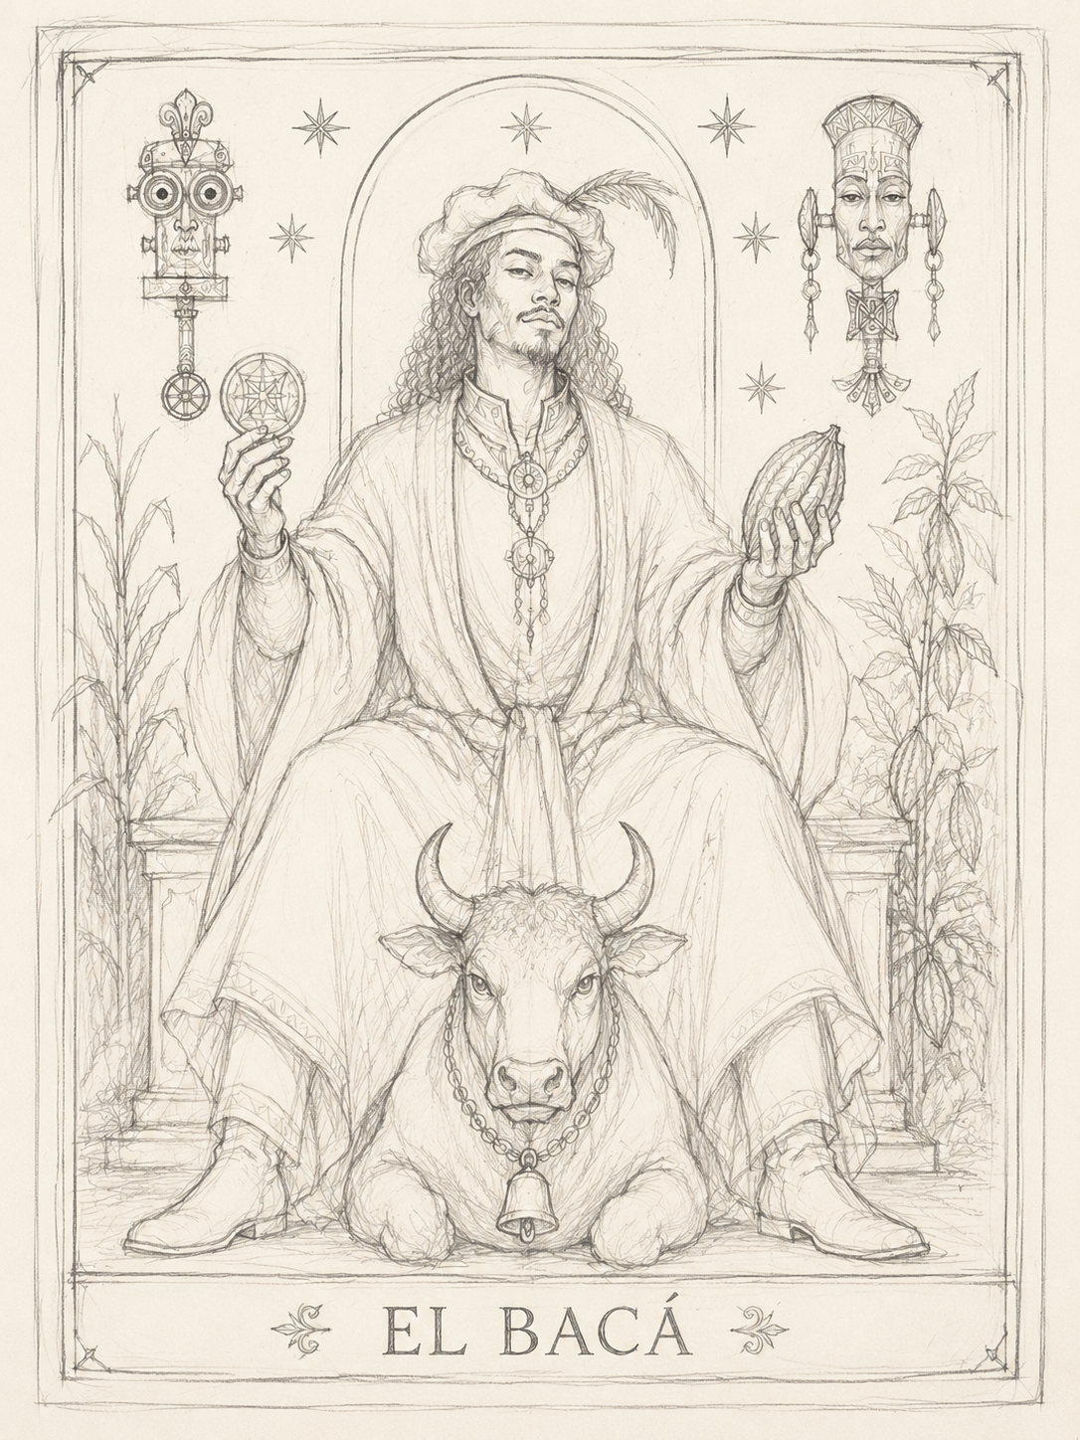  Line sketch | 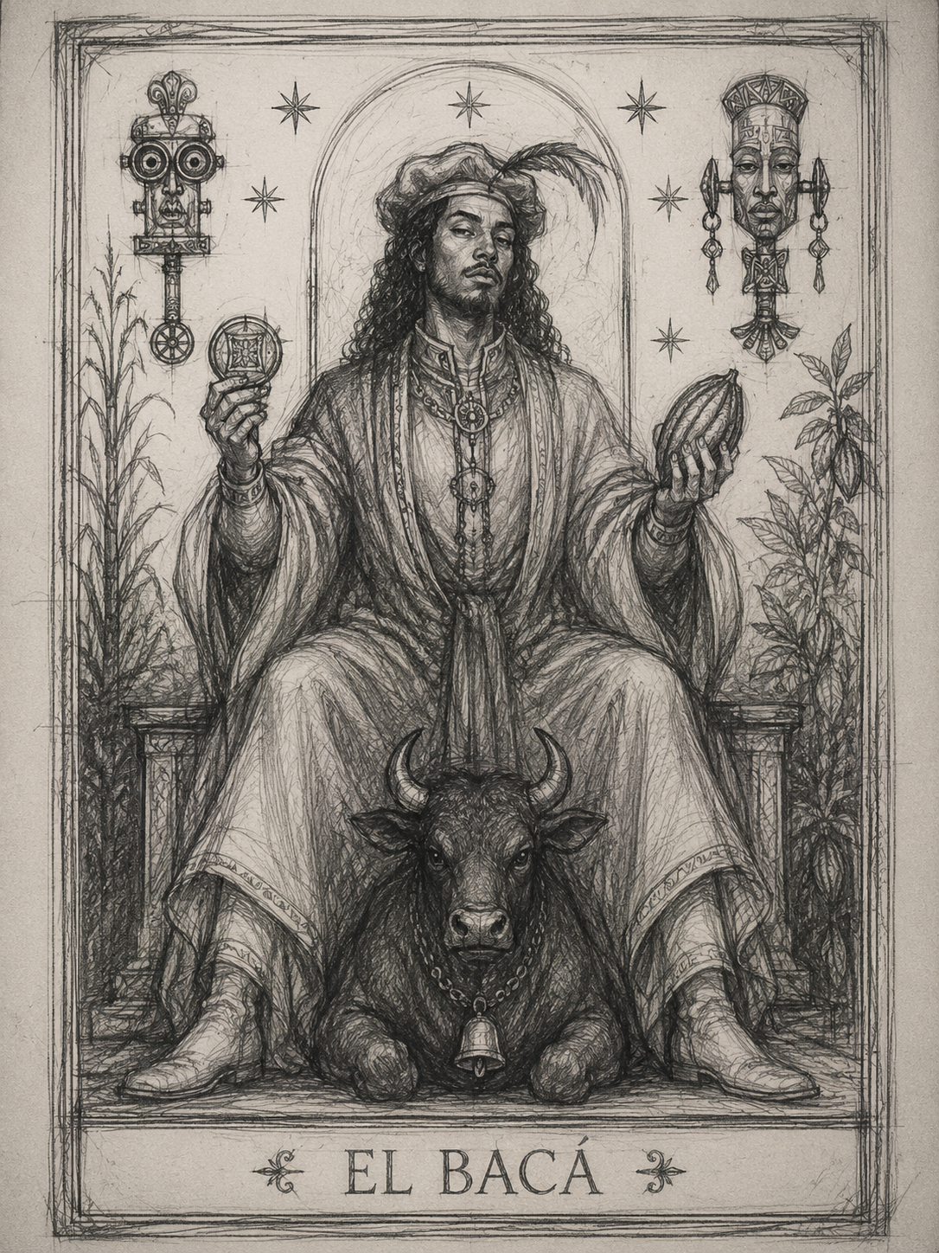  Developed sketch | Final artwork

La Ciguapa
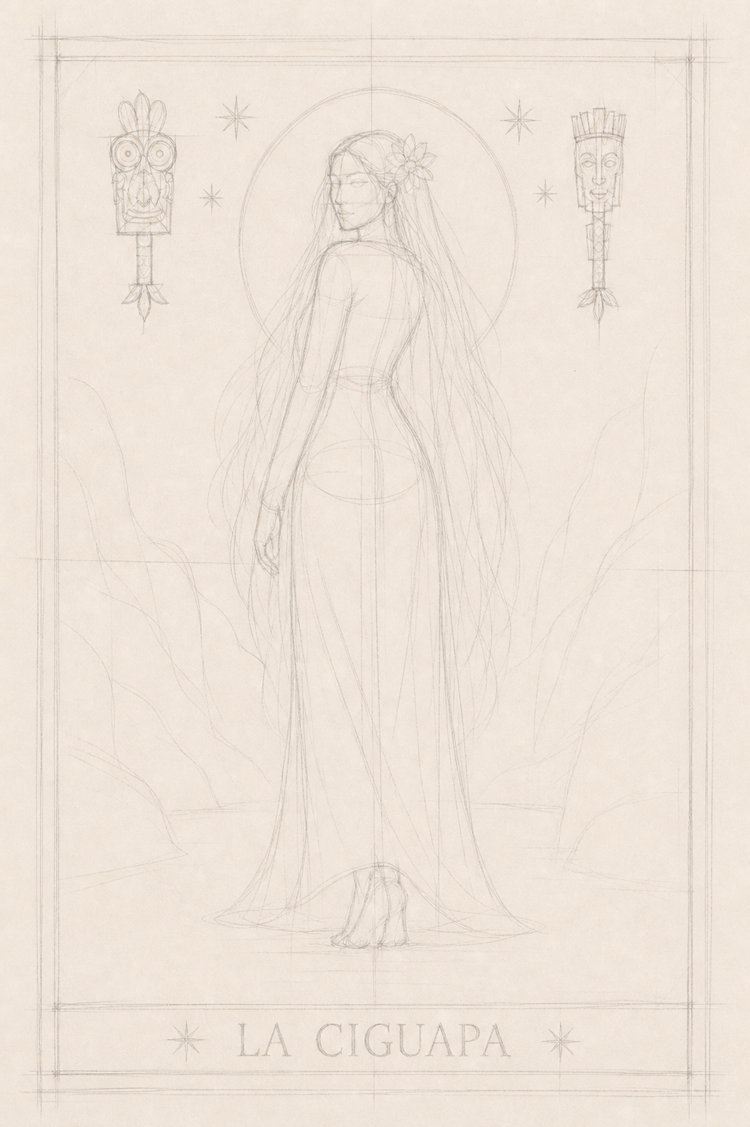  Line sketch | 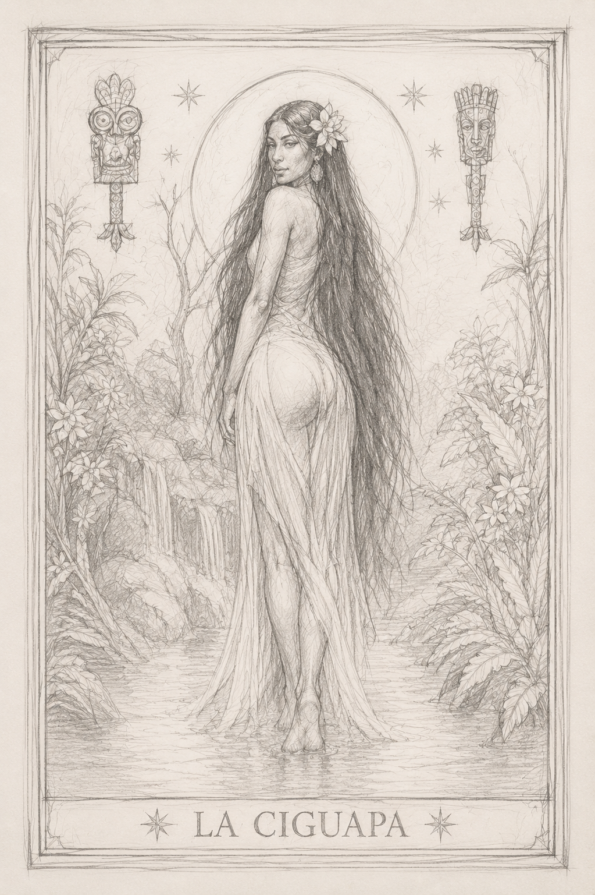  Developed sketch | 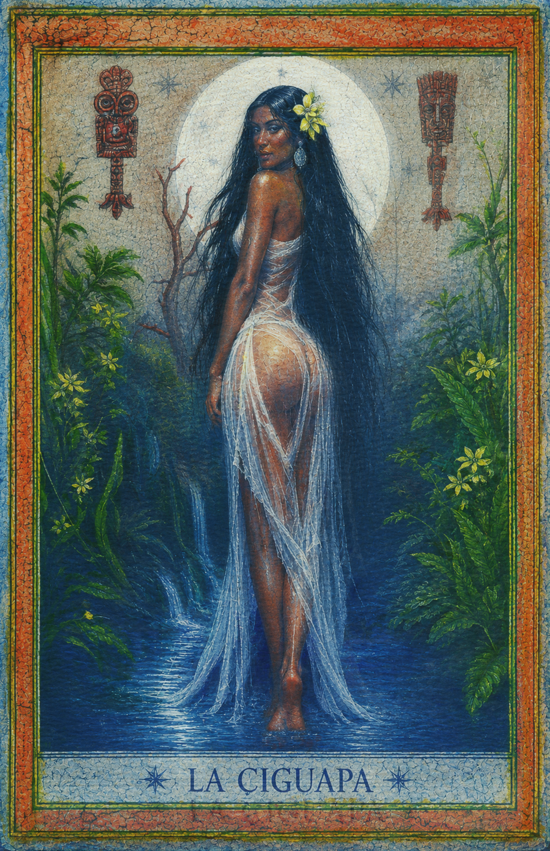  Final artwork

Horizontal visual proposal
A 16:9 diptych split by a fractured gold line. The Bacá on charcoal with a deep-red glow; the Ciguapa entering blue-black forest. Two central footprints point in opposite directions. Text: “The pact that binds. The footprint that escapes.”
Suggested artworks: 03_baca_obra_final.png and 06_ciguapa_obra_final.png.

References
• Derby, Lauren. Bêtes Noires: Sorcery as History in the Haitian-Dominican Borderlands. Duke University Press, 2025. [source: dukeupress.edu]
• Candelario, Ginetta E. B. “La ciguapa y el ciguapeo: Dominican Myth, Metaphor, and Method.” Small Axe, 2016. [source: researchgate.net]
• Dominican Academy of History, bibliographic record for Angulo Guridi’s La Ciguapa (1866). [source: catalogo.academiadominicanahistoria.org.do]

The Dead Do Not Leave: Papá Liborio and the Jupías
He was a man before he became legend. They were spirits before they became cards. Between the mountains of San Juan and the Taíno realm of the dead rises a Dominican question: what happens when a community refuses to forget?
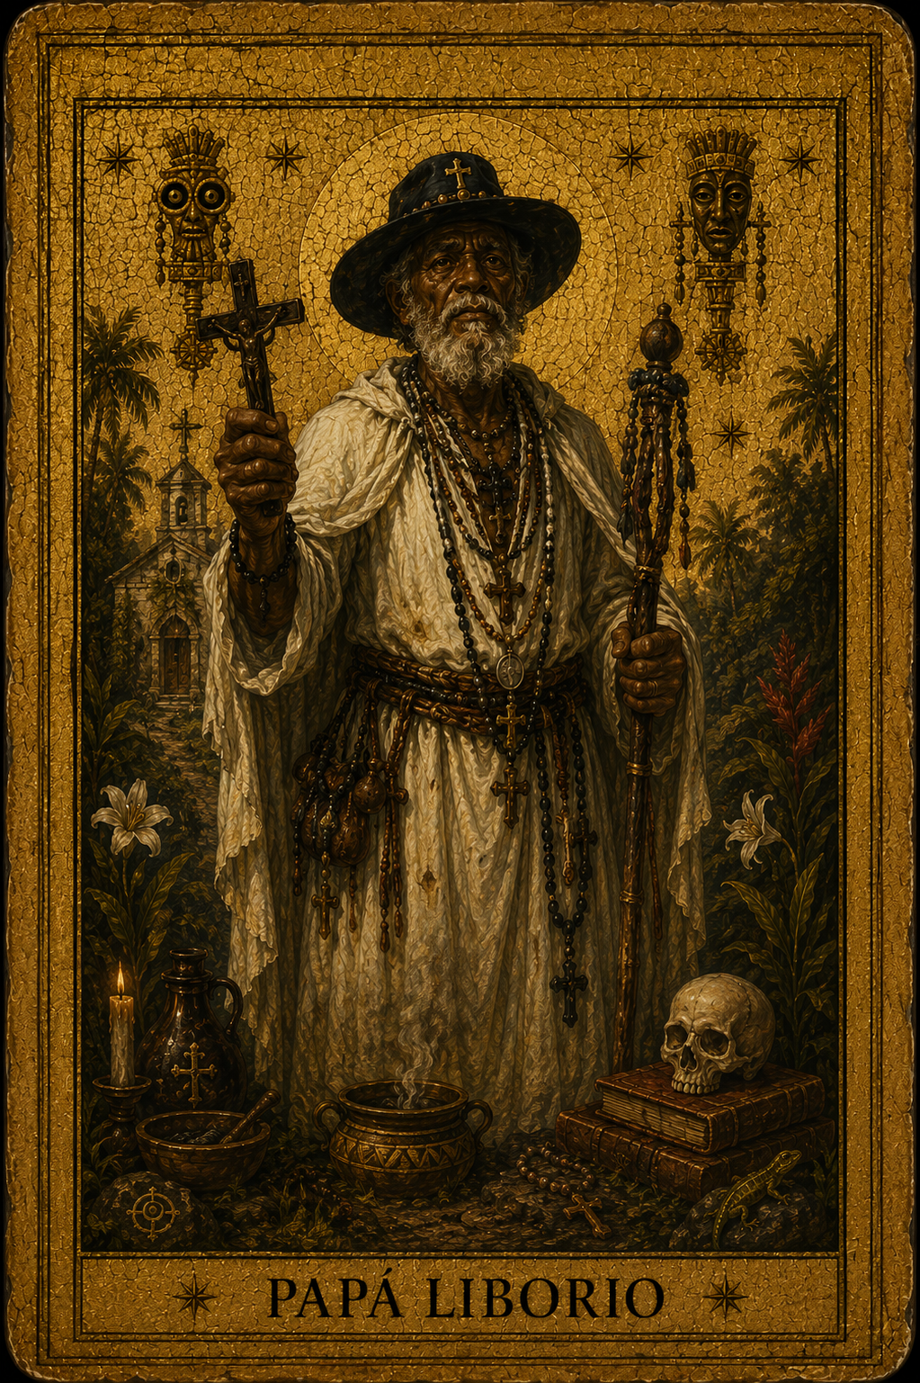
“Liborio is not dead,” a popular décima insists. The line does not have to deny a date. Its truth belongs to another order: a person can die and continue to act inside a community.
The Jupías say something similar from a much older time. In the Taíno cosmology recorded—imperfectly and through a colonial lens—by Ramón Pané, the hupía or opía was the spirit of the dead person. It left the body without disappearing from the universe. It returned at night, assumed forms, and continued to brush against the world of the living.
Papá Liborio and the Jupías are not the same kind of figure. One belongs to the documented history of the twentieth century; the others to an Indigenous cosmology known through problematic sources. Their force comes from not confusing them: two different roads toward persistence.

Papá Liborio: from persecuted man to collective presence
Olivorio Mateo was born in 1876 in the San Juan region. The movement that took his name formed in 1908, after he said he had received a divine mission during a disappearance. He became a healer, preacher, and leader of a rural community, offering spiritual relief, attention, moral order, and cohesion in a territory with limited institutional presence.
Political power read that community differently. The Dominican National Archives explains that Liborio was treated as a threat and persecuted, especially during the United States military occupation. He died in combat in 1922.
Only 14 years separate 1908 from 1922—enough to generate a movement whose memory crossed the century. Contemporary studies insist that reducing Liborio to a “sorcerer” or folkloric curiosity erases history: the relations among Afro-Dominican spirituality, rural leadership, resistance, and sovereignty.
That tension defines his arcano. Papá Liborio can signify embodied faith, communal care, and resistance against authority unable to recognize popular legitimacy. His shadow requires vigilance: limitless charisma, obedience, weaponized martyrdom, or a leader mistaken for truth itself.
Papá Liborio asks: Is the community following a voice, or has that voice learned to listen to the community?

The Jupías: the soul that returns at night
The word appears in several forms: hupía, opía, and within this project, jupía. A recent publication from the University of Turin’s Museum of Anthropology and Ethnography describes it as the “spirit or soul of the dead.” After physical decomposition, the hupía traveled to Coaybay, the realm of the deceased, but could re-enter the ordinary world at night, associated with the forest, guava fruit, and nocturnal beings such as bats and owls.
This material must be read humbly. Pané’s Account of the Antiquities of the Indians is a decisive early source on Antillean religion, but it was commissioned within conquest. Scholars have described its failure of translation: complex Taíno concepts were forced into Christian categories such as idol, god, or superstition. We do not possess a transparent window into the fifteenth century.
That limitation belongs inside the card. The Jupías cannot become archaeological decoration or generic ghosts. They also remind us that this memory arrives in fragments produced by people participating in its destruction.
In light, the Jupías signify ancestral memory, dream, continuity, counsel from the absent, and nonlinear time. In shadow: an invasive past, arrested grief, idealization of the dead, or inherited voices that prevent life.
The Jupías ask: What part of my life belongs to those who are gone, and what must I return to them?

Faith, archive, apparition
Together, the cards ask who has the right to remain.
Papá Liborio persisted because followers refused to accept that a political death canceled his meaning. The Jupías persisted because even a colonial archive could not entirely erase the Taíno idea of an active relationship between living and dead.
Memory is not passive. It heals, organizes, warns, and makes claims. It can also manipulate. These cards do not automatically celebrate everything ancestral or sacred. They ask what we do with it.

Four numbers and an absence
- 1876: Olivorio Mateo’s birth.
- 1908: the beginning of the Liborista movement, according to the National Archives.
- 1922: Liborio’s death during military persecution.
- 14 years: the interval between the movement’s formation and its leader’s death.
- One unquantifiable absence: the Taíno knowledge lost or distorted through conquest.
The final figure matters most. Responsible research does not fill every gap with fantasy. Sometimes it marks the opening and allows the viewer to feel its weight.

Giving form without taking the body
Papá Liborio’s card must preserve the man inside the myth: mountain, community, a human gaze, traces of persecution and healing. It needs no easy halo. Its power rises from the tension between vulnerability and presence.
The Jupías should feel multiple—not European white ghosts, but presences moving in and out of landscape: unstable bodies, nocturnal eyes, guavas, wings, roots, faces almost recognized. The image may conceal more than it reveals because the source itself arrives incomplete.
In The Arcanos of the House, both figures meet at memory’s threshold. He reminds us that a community can turn the persecuted into a symbol. They remind us that the dead never fully accepted the language conquerors used to name them.

LinkedIn version
Papá Liborio was a man before he became legend.
Olivorio Mateo was born in 1876. His religious movement began in 1908 in the San Juan region. He was healer, preacher, and community leader; he was also persecuted as a political threat and died in 1922 during the United States occupation.
The Jupías belong to a different archive. The hupía or opía was, in the Taíno cosmology recorded by Ramón Pané, the spirit of the dead person—a presence traveling to Coaybay and capable of returning at night to the living world.
They should not be conflated. Liborio is documented history crossed by myth. The Jupías are an Indigenous concept transmitted through an incomplete colonial source.
In The Arcanos of the House, their encounter asks: how does a community remain when power attempts to erase its memory?
Papá Liborio signifies faith, care, and resistance, but also the danger of limitless charisma. The Jupías signify ancestral continuity, but also a past that refuses to let the present live.
The dead do not leave. They change language.

Horizontal visual proposal
A 16:9 night mountain. Papá Liborio stands human and frontal in the left third; three translucent Jupías appear among branches and fruit on the right. A line of light connects 1876—1908—1922 and vanishes into darkness. Text: “The dead do not leave. They change language.”
Suggested artworks: papa_liborio.png and las_jupias.png.

References
• Dominican National Archives. “El Archivo General de la Nación pondrá en circulación el libro Con la Palabra de Dios.” November 25, 2024. [source: agn.gob.do]
• Tapia, Ariel. “Papá Liborio, entre Révolution et mystification.” Sociocriticism 36, 2022. [source: interfas.univ-tlse2.fr]
• University of Turin Museum of Anthropology and Ethnography. Digital Cemí, 2026. [source: museoantropologia.unito.it]
• Tavárez, David. “La ausencia de los dioses taínos.” [source: scielo.org.mx]

When Night Takes Form: The Man in the Black Hat and the White Lady
He appeared in the darkness of a city under pressure. She walks through roads and houses in many countries wearing a dress that never seems to gather dirt. Two silhouettes reveal how fear gives a body to an era.
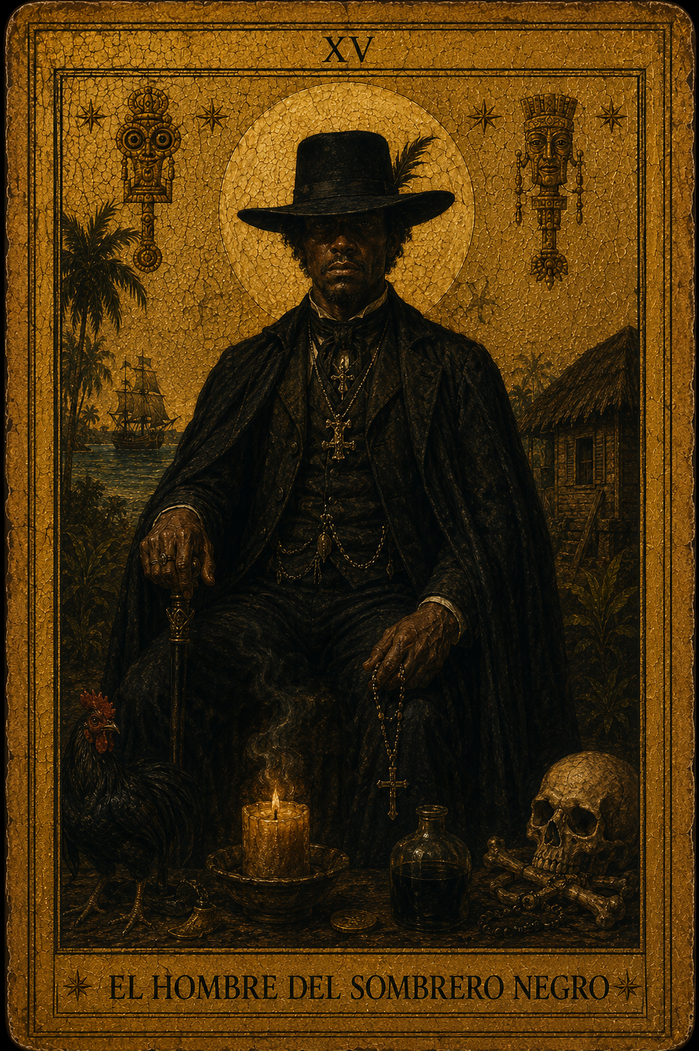
The silhouette arrives before the face.
A black brim cuts around a man’s head. A pale dress pauses beside the road. Distance protects the mystery: if the figure came too close, perhaps it would become a person; if it vanished entirely, only fear would remain. Legend keeps it precisely at the edge.
The Man in the Black Hat and the White Lady belong to this theater of apparition. They have neither the same genealogy nor a single authoritative version. One is tied to a relatively recent Dominican urban episode. The other belongs to an international family of migratory legends that communities adapt to their own accident, house, curve, or loss.

The Man in the Black Hat: fear on the avenue
A report in the Dominican newspaper El Nacional places public circulation of the Man in the Black Hat between 1987 and 1990, around Charles de Gaulle Avenue and the Las Américas highway. At the time, the area was sparsely populated and poorly lit. Rumors associated a man dressed in black with attacks against women and university students.
The article preserves contradictory testimony. Some people said they saw him. Others said he never existed and that the myth may have been used to redirect public attention during a period of political tension. His existence was never demonstrated.
That uncertainty is the center of the story, not a defect. The figure condenses real fears: sexual violence, unsafe urban space, opaque authority, and rumor moving faster than evidence. The legend places one hat on threats that in reality possess many faces.
The figure also resonates with a wider contemporary pattern: the shadow person or nocturnal intruder. Sleep-paralysis research cannot explain every black-hat narrative or diagnose historical witnesses. It does show that sensing a threatening presence and seeing an “intruder” are documented human experiences.
A systematic review of 35 studies and 36,533 participants found that 7.6% of the general population, 28.3% of students, and 31.9% of psychiatric patients had experienced at least one episode of sleep paralysis. The figures do not prove the Man in the Black Hat. They help explain why a motionless silhouette near a bed or in darkness can feel universally recognizable.

The White Lady: the apparition that migrates
There is no single Dominican White Lady with a stable biography. That must be stated clearly. The figure belongs to a global family of legends: women in white connected to roads, accidents, betrayal, interrupted weddings, violent death, or houses unable to release them.
Folklorists call stories “migratory” when they travel and acquire local details. Elizabeth Tucker’s study of the White Lady of Devil’s Elbow in New York demonstrates the process. A roadside legend linked to an old death changed across decades. The apparition became Victorian lady, bride, and prom queen; teenagers even impersonated the ghost to frighten drivers. The core survived while the narrative clothing adapted to each generation.
The White Lady in The Arcanos of the House arises from that mechanism and from Caribbean accounts of feminine apparition. She claims no invented ancient pedigree. Her authenticity lies elsewhere: countless communities have needed to imagine a woman visible only when the world sleeps.

Two forms of witness
The Man in the Black Hat represents faceless threat. In light: vigilance, instinct, the courage to name a danger a community prefers to conceal. In shadow: paranoia, instrumentalized rumor, and fear used to control bodies and spaces.
The Man in the Black Hat asks: What danger am I actually perceiving, and who benefits when I cannot see it clearly?
The White Lady represents memory asking for a witness. In light: grief, intuition, message, transition, and recognition of absence. In shadow: repetition, tragic idealization, guilt, and fascination with women’s suffering.
The White Lady asks: What story returns because no one listened while it still had a voice?
Together, the cards create an ethics of looking. He may be a rumor used to police women, but he may also be the shape taken by real danger when institutions refuse to name it. She may reduce a dead woman to a romantic object, but she may also demand that the viewer recognize the subject of an erased history.

Mystery does not require a lie
An alluring campaign might claim that both figures have been seen for centuries at one exact location. It would be effective for seconds and weak forever. The Arcanos of the House chooses a different strategy: show the open file.
We know the Dominican black-hat rumor was publicly situated in the late 1980s. We know the White Lady belongs to an international migratory legend pattern. We know sleep paralysis and intruder perceptions are measurable experiences. We also know no statistic contains the full experience of sensing a presence in a dark room.
The most persuasive darkness does not hide the research. It uses research to tighten the tension.

How to paint an apparition
The Man in the Black Hat must not reveal too much. The image needs distance, urban geometry, sodium light, and a road that seems to end behind him. The hat works as an eclipse: it does not decorate the head; it cancels the face.
The White Lady needs a different treatment. White is not innocence. It is overexposure, burial cloth, light erasing detail. Her body should almost dissolve into wall or fog. If the viewer sees her too clearly, the card fails.
In Turin, the two works close an arc begun with pact, flight, faith, and ancestral memory. Urban night and pale apparition are not an ending. They are the final question before the card turns:
When no one can prove what you saw, which part of you continues to believe?

LinkedIn version
Between 1987 and 1990, a rumor moved through areas near Charles de Gaulle Avenue and the Las Américas highway in Santo Domingo: a man dressed in black haunted a dark, sparsely inhabited zone. Some claimed to see him. Others argued he never existed. His existence was not demonstrated.
The White Lady has a different history. She belongs to no single street or country. She is a migratory folkloric pattern—the woman in white tied to a curve, death, house, or unfinished farewell. Her biography changes with the community.
In The Arcanos of the House, both figures become an investigation of witness.
The Man in the Black Hat asks: What danger is real, and who benefits from keeping it faceless?
The White Lady asks: What story returns because no one listened in time?
A review of 35 studies involving 36,533 participants found that 7.6% of the general population had experienced sleep paralysis at least once; among students, the figure was 28.3%. That does not “explain” a legend. It shows how deeply human the sensation of a nocturnal intruder can be.
Mystery does not require a lie. It needs a shadow precise enough for the viewer to complete the face.

Horizontal visual proposal
An almost-monochrome 16:9 road at night. The Man in the Black Hat occupies the far left as black absence; the White Lady occupies the right as burned-out light. Between them: “What did you see when no one could prove it?” Dark red and aged silver details.
Suggested artworks: el_hombre_del_sombrero_negro.png and la_dama_blanca.png.

References
• Gómez, Juan Julio. “El ‘hombre del sombrero negro’: ¿mito o realidad?” El Nacional, August 2, 2022. [source: elnacional.com.do]
• Sharpless, Brian A., and Jacques P. Barber. “Lifetime Prevalence Rates of Sleep Paralysis: A Systematic Review.” Sleep Medicine Reviews, 2011. [source: pmc.ncbi.nlm.nih.gov]
• Tucker, Elizabeth. “The White Lady of Devil’s Elbow.” Children’s Folklore Review 34, 2012. [source: scholarworks.iu.edu]
• de Sá, José F. R., et al. “Sleep Paralysis in Brazilian Folklore and Other Cultures.” Frontiers in Psychology, 2016. [source: pmc.ncbi.nlm.nih.gov]

